Question 1: What is Data Loading in Power BI and why is it considered the first step of analysis?
Answer:
Data Loading is the process of importing raw data from a source (provided COVID-19 table) into the Power BI internal storage engine (VertiPaq).
It is considered the first step because:
- Foundation: You cannot create visualizations, filters, or calculations until the data is physically "available" within the model.
- Schema Definition: During loading, Power BI identifies the columns (Country, Cases, etc.) and initial data types, which sets the stage for all future analytical work.

Question 2: Explain the difference between “Load” and “Transform Data” in Power BI.
Answer:
When you connect to your dataset, you are given two primary choices:
- Load: This pulls the data directly into Power BI exactly as it appears in the source. Use this only if your data is perfectly clean (no missing dates, no empty "Vaccination_Status" cells).
- Transform Data: This opens the Power Query Editor. This is the preferred choice for your specific dataset because it allows you to:
  - Fix the missing values in the Vaccination_Status column.
  - Convert the numeric "Date" format (e.g., 43831) into a readable Date format (e.g., 01/01/2020).
  - Remove any duplicates or filter out unnecessary countries.

Question 3: What is a Fact Table and a Dimension Table? Give examples from the dataset.
Answer:
In data modeling, we categorize tables based on the type of information they hold:
- Fact Table: A table containing quantitative data (numbers/metrics) that change over time. It records "events."
  - Example from your data: The core dataset is a Fact Table because it stores daily observations of Confirmed_Cases, Deaths, and Tests_Conducted.
- Dimension Table: A lookup table that contains descriptive attributes used to filter and group the Fact Table.
  - Example from your data: If you had a separate table listing Country Details (Country Name, Population, Continent, ISO Code), that would be a Dimension Table. You would use it to filter the "Fact Table" by Continent.

Question 4: Why is Star Schema preferred over Snowflake Schema in Power BI?
Answer:
A Star Schema consists of one Fact table connected directly to multiple Dimension tables (looking like a star). A Snowflake Schema is more complex, where Dimension tables are connected to other sub-dimension tables.
Star Schema is preferred because:
- Simplicity: It is easier for Power BI to navigate. Fewer "joins" (links) between tables mean the reports load much faster.
- Performance: Power BI is optimized for the Star Schema. Snowflake schemas require more complex relationships, which can slow down "slicers" and filters on large datasets.
- Usability: It is more intuitive for users to build reports when they only have to look at one central table for numbers and surrounding tables for categories.
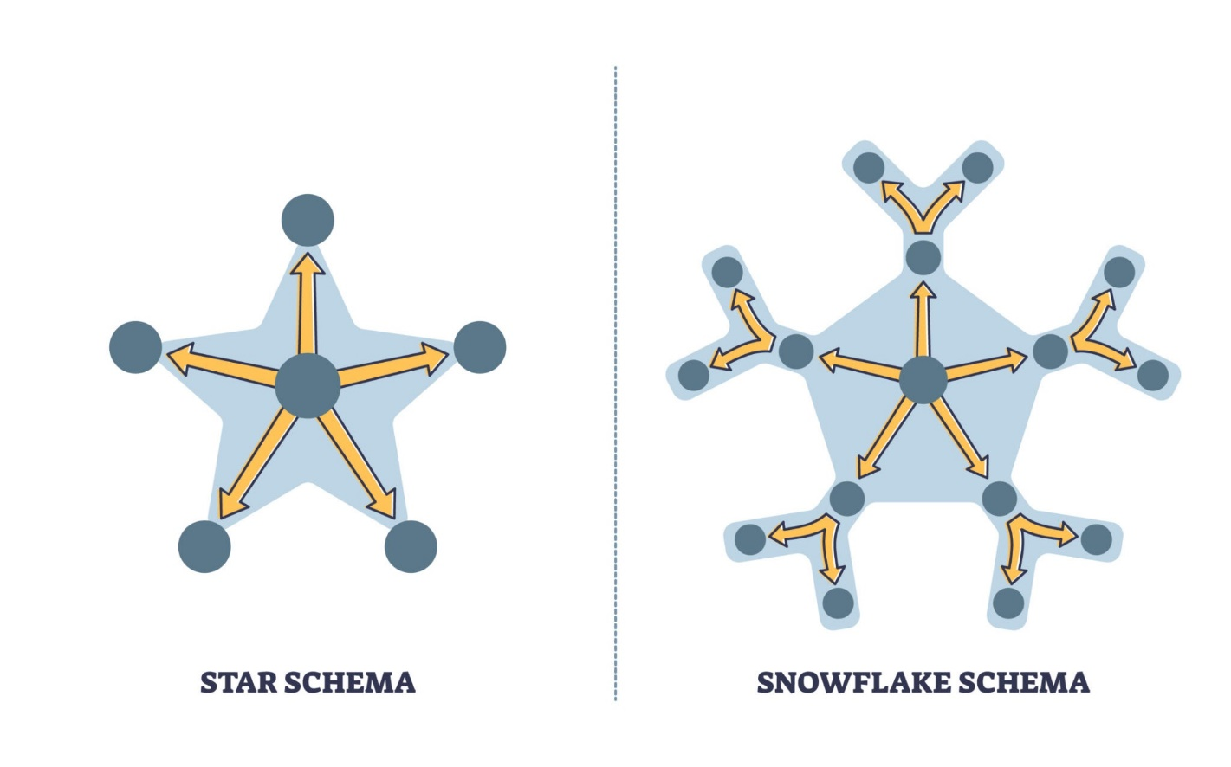

Here are the step-by-step instructions for the practical tasks using Power Query and DAX in Power BI, based on the COVID-19 dataset you provided.

Question 5: Identify and remove duplicate records based on Date, Country, and State.
Answer:
In Power Query, you can remove duplicates based on a combination of specific columns to ensure each entry is unique for a location on a specific day.
- Open Power Query Editor (Transform Data).
- Hold the Ctrl key and click on the headers for Date, Country, and State.
- Right-click on any of the highlighted headers.
- Select Remove Duplicates.
- Why: This ensures that if "UK - State_A" was accidentally entered twice for the same date, only one record remains, preventing the inflation of case numbers.

Question 6: Identify and replace null values in Vaccination_Status.
Answer:
Your dataset has several blank entries in the Vaccination_Status column. To clean this:
- In Power Query, right-click the Vaccination_Status column header.
- Select Replace Values.
- In the Value to Find box, leave it empty (or type null if it explicitly says null).
- In the Replace With box, type "Unknown" or "No" (depending on your reporting standard).
- Click OK.

Question 7: Create a new column to calculate Recovery Rate.
Answer:
The Recovery Rate is a vital metric. You can create this as a Calculated Column using the following DAX formula in the Data View:
Formula:
$$Recovery Rate = DIVIDE('Table'[Recovered_Cases], 'Table'[Confirmed_Cases], 0)$$
Steps to implement:
- Go to the Data View (table icon on the left).
- Click New Column in the Calculations group.
- Enter the formula above.
- Select the new column and change the Format to Percentage in the "Column Tools" ribbon.
- Note: Using the DIVIDE function is better than using / because it automatically handles "Division by Zero" errors if a country has 0 confirmed cases.

Question 8: Create a summarized table showing total confirmed cases by Country.
Answer:
You can achieve this using the Summarize function in DAX to create a new calculated table.
Steps:
- Go to the Modeling tab and click New Table.
- Enter the following DAX formula:
Code snippet
CountrySummary =
SUMMARIZE(
'Table',
'Table'[Country],
"Total Confirmed", SUM('Table'[Confirmed_Cases])
)
Alternative (Visual Method):
If you don't need a physical table and just want to show this in your report:
- Go to Report View.
- Select the Table Visual.
- Drag Country and Confirmed_Cases into the "Columns" bucket. Power BI will automatically sum the cases for you.

